# KAT VR SDK Instructions

目录

KAT VR SDK Instructions 1

Introduction to KAT Unity Integration SDK 2

Developer Support 2

Device Support 2

Getting Started 5

1. Overview 5

2.Configuration of The Development Environment 5

KAT VR Devices 6

PC 9

VR HMD 9

Install the Unity editor 9

3.Import the KAT Unity Integration SDK 11

Create a project and install the OpenXR Plugin 11

SDK Functions 15

4.Debug and build the app 22

KAT VR Devices 22

VR HMD 23

Build Settings： 23

Developer Best Practices Guide: 25

## Introduction to KAT Unity Integration SDK

KAT Unity Integration SDK enables a series of functions for KAT VR devices, including the data of foot movement and waist angle, control of haptics, LED light and sitting posture module, etc. You can use KAT Unity Integration SDK to develop VR games and applications compatible with KATVR devices, build your own unique VR universe, and provide users with immersive VR experience.

Before using the KAT Unity Integration SDK, it is recommended to read the official instructions to learn more about the Unity XR.

## Developer Support

[Please feel](mailto:Please%20feel) free to contact us at developer@katvr.com if you have any question~~s~~ about application development, our support team will reply to you as soon as possible after receiving the email.

## Device Support

The SDK supports all KAT product lines. as follows:

KAT Walk mini S

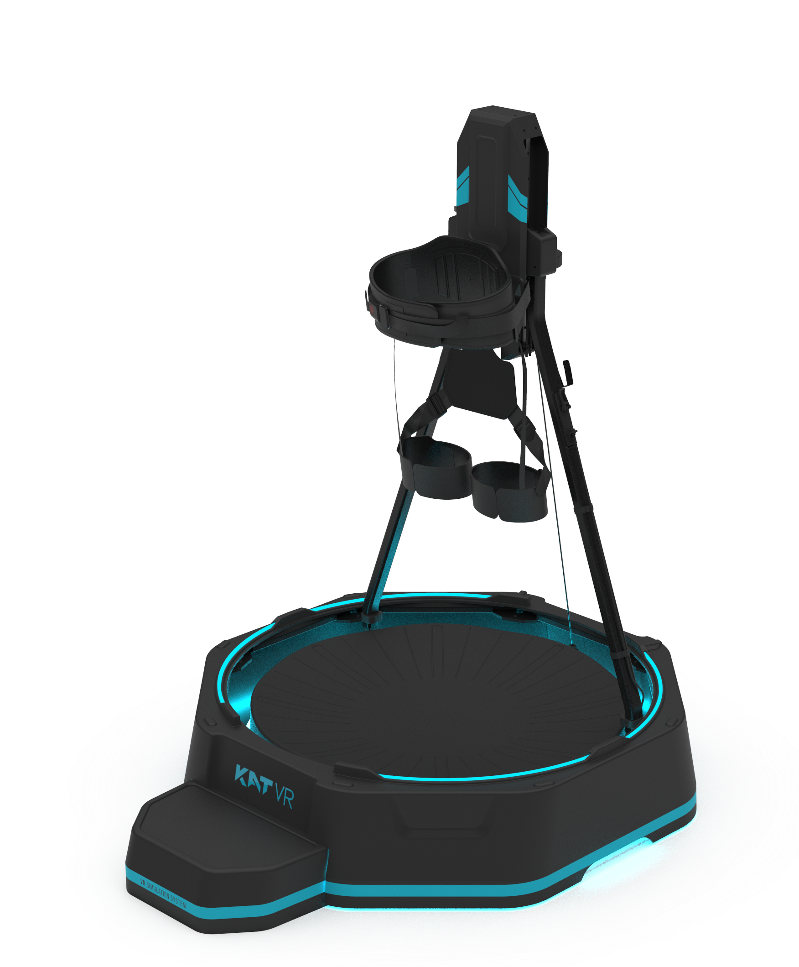

KAT loco S

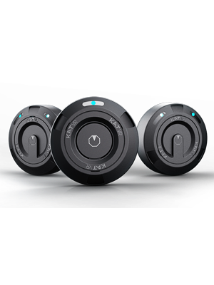

KAT Walk C

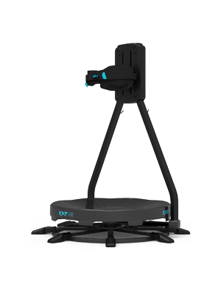

KAT Walk C 2

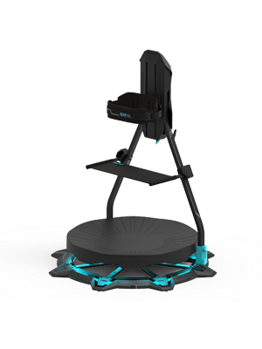

## Getting Started

## 1. Overview

"Getting Started - Overview" takes Unity2021.3.11f1c2 version for reference to introduce how to use the KAT Unity Integration SDK to build a basic XR scene based on the Unity engine, and embed it into an XR application running on the KAT VR devices.

If you are a novice developer, we recommend you carefully read and follow the guide to develop your first basic XR application to start your first steps to explore the XR world. If you are interested in XR applications and already have a certain understanding of app development, you can skip some of the content and just pay attention to the most important and helpful parts as needed.

## 2.Configuration of The Development Environment

Development environment configuration is a necessary prerequisite for developing XR applications running on KAT VR devices. This article explains it from two aspects: hardware and software requirements as well as development tools.

### KAT VR Devices

The KAT VR devices can be used to debug and test applications.

* Model: KAT Walk mini S, KAT Ioco S, KAT Walk C, KAT Walk C 2
* Make sure the corresponding KAT VR device is correctly connected to the computer and the data normally displayed in the corresponding software.

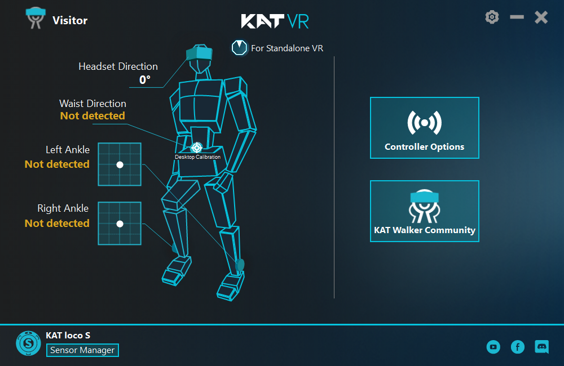

（KAT loco S）

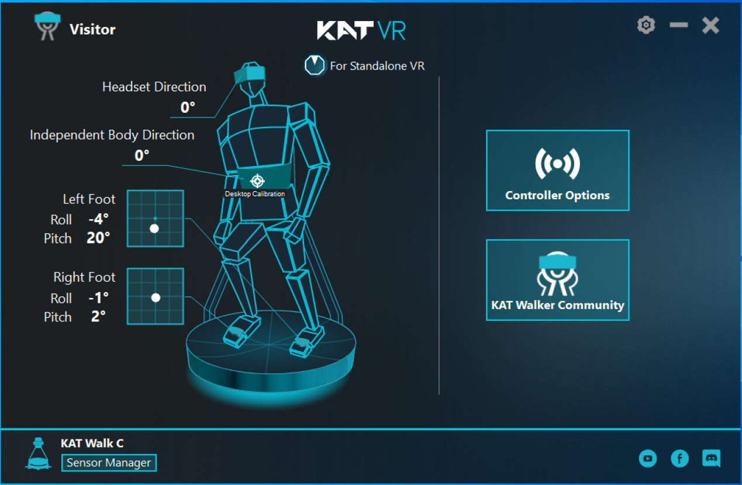

（KAT Walk C）

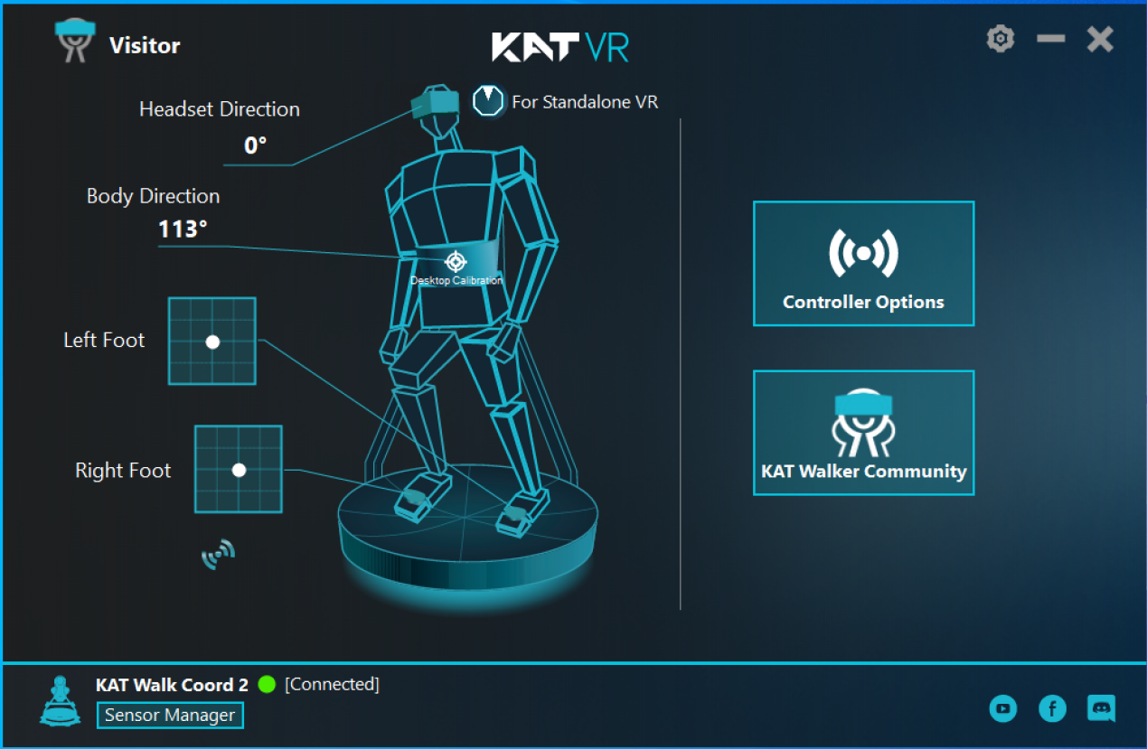

(KAT Walk C 2)

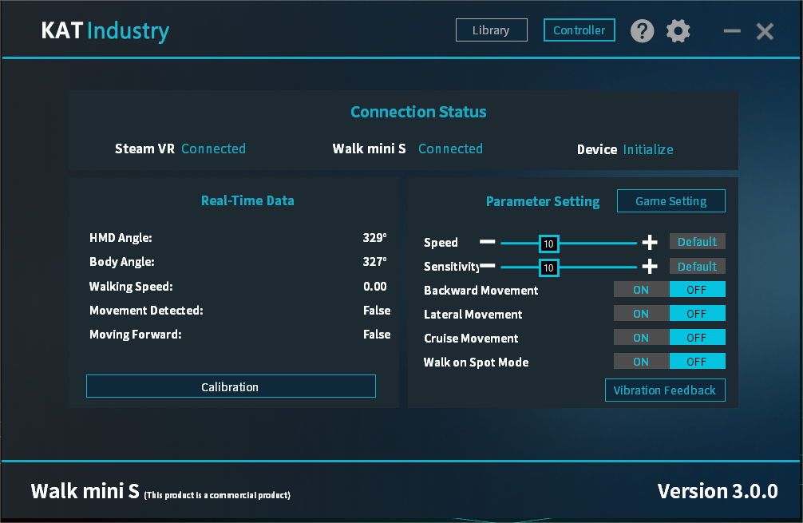

（KAT Walk mini S）

* If the KAT VR device cannot be connected to the computer for some reasons, you can use the KAT Device Simulator software in the KAT Unity Integration SDK development kit to simulate hardware connection and data output.

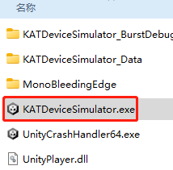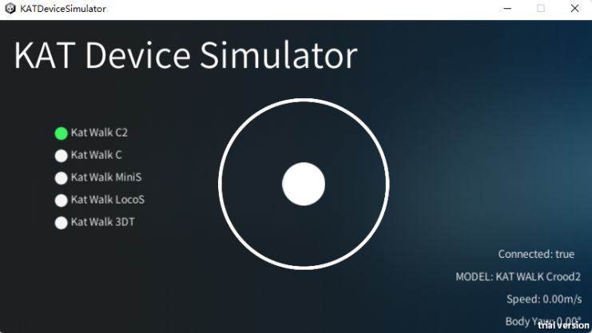

### PC

It is recommended to use the Windows 10 operating system as the development environment for VR games and applications compatible with the KAT Walk mini S,KAT Ioco S,KAT Walk C,KAT Walk C 2. PC system configuration requirements are as follows:

* CPU: Intel i5-4590 /AMD Ryzen 51500X or higher
* Graphics Card: NVIDIA GTX 1060/ AMD Radeon RX 480 or better
* RAM: 8GB or higher
* Port: USB3.0

### VR HMD

VR HMD can be used to debug and run applications. For the development method of the corresponding HMD, please refer to the official developer website of the HMD of your choice.

### Install the Unity editor

You can use the free version or professional version of the Unity Editor to develop VR games and applications compatible with the KAT Walk mini S, KAT Ioco S, KAT Walk C and KAT Walk C 2. For novice developers, before officially using the Unity Editor, it is recommended to read the official instructions to learn the basics of Unity XR. The editor installation steps are as follows:

1. Visit the Unity download page and download the Unity Hub.

2. Open the Unity Hub.

3. Select ‘Install’ from the left navigation bar.

4. On the Installation page, click ‘Install Editor’.

5. Find the target editor version and click ‘Install’.

6. In the Add Module window, check Windows Build Support (IL2CPP) and Windows Dedicated Server Build Support

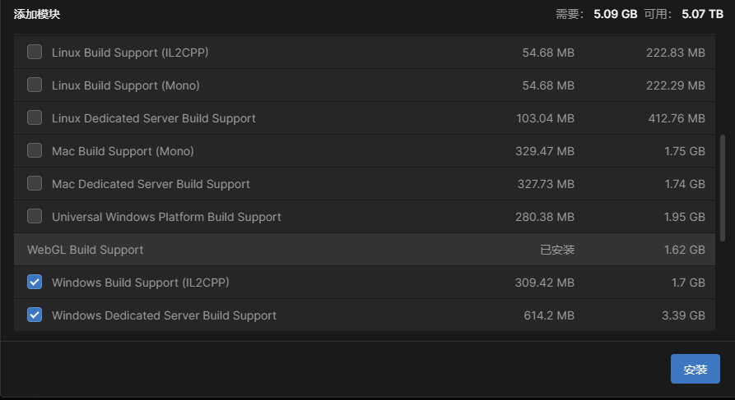

7. Click ‘Continue’.

8. Read the relevant terms and conditions, and tick ‘I have read and agree to the above terms and conditions.’

9. Click ‘Install’.

## 3.Import the KAT Unity Integration SDK

KAT Unity Integration SDK is the official SDK development tool provided by KAT VR based on Unity XR, which includes the functions, components, plug-ins and Demo required to develop VR games and applications compatible with the KAT Walk mini S, KAT Ioco S, KAT Walk C, KAT Walk C 2.

Create a project and install the OpenXR Plugin

#### （1）Create a project

Before installing the OpenXR Plugin and importing the KAT SDK, you need to create a new project in Unity Hub by following steps:

1. On the Unity Hub homepage, click ‘Project > New Project’ to turn to the New Project page.

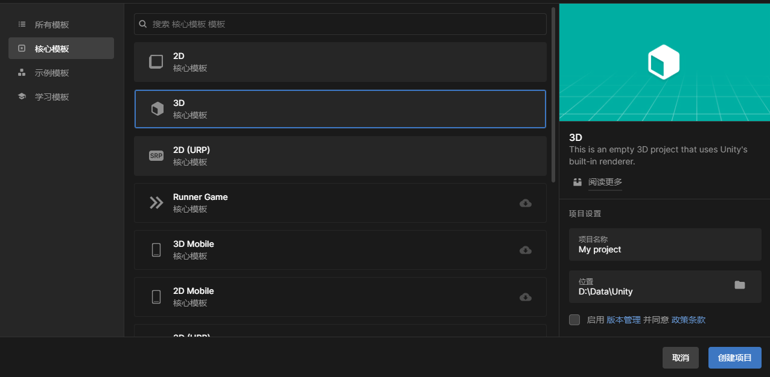

1. Select ‘Core Templates > 3D.’
2. In the project setting area, set the project name and storage directory.

! Note: The project name and storage directory cannot contain Chinese characters

1. Click ‘Create Project.’Once the project is initialized, it will automatically turn to the Unity editor page.

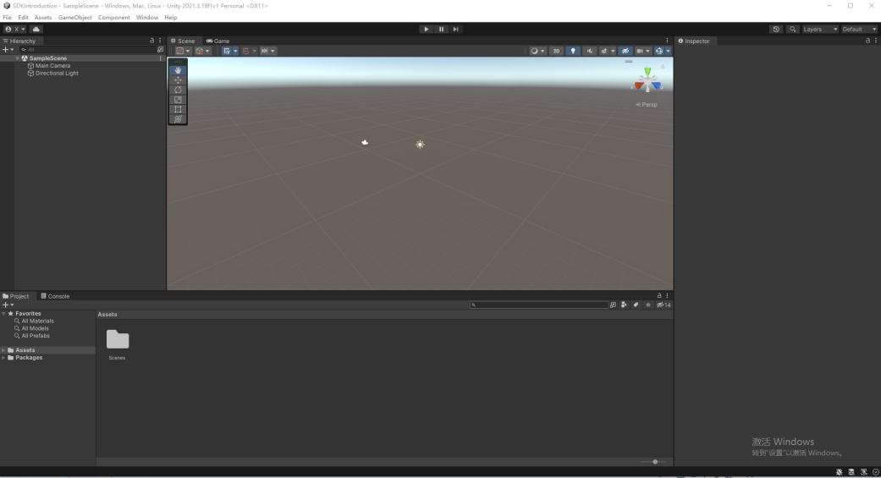

#### Install the OpenXR Plugin

1. On the Unity editor page, click ‘Window > Package Manager.’ Change the Packages in the upper left corner to Unity Registry, then search for OpenXR

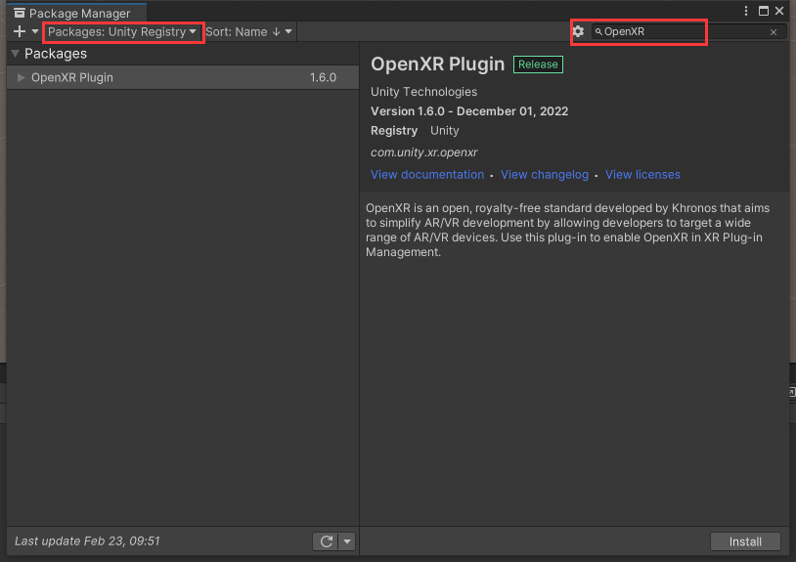

1. Click ‘Install’ as shown in the figure to complete the installation.

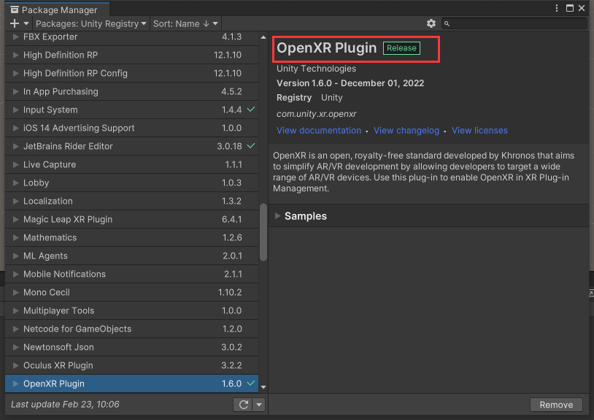

#### Import SDK

1. Drag and drop the KAT Universal SDK xx (xx represents the version) unitypackage file in the Unity folder of the SDK file package into the Assets of the unity project,then import all files into the project.

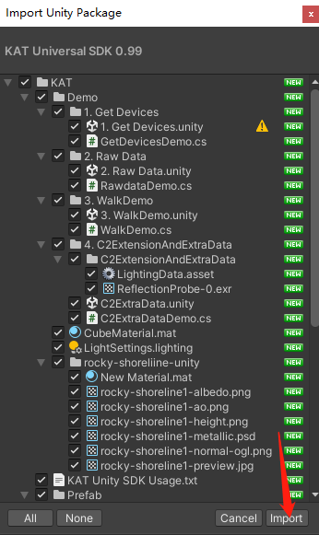

1. Importcompleted: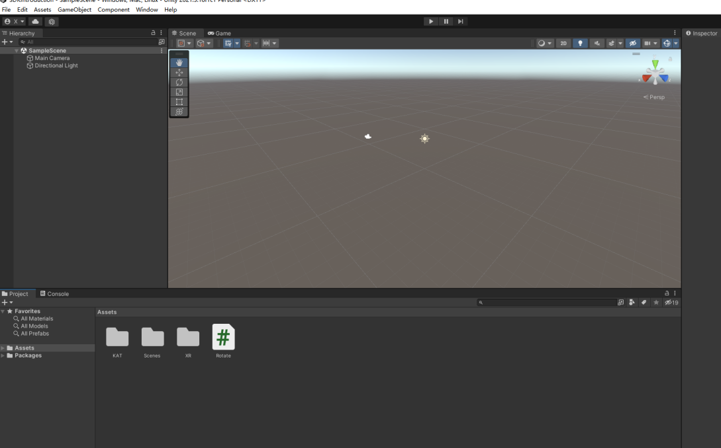

### SDK Functions

After the KAT Unity integration SDK is imported, you’ll see three folders, namely Demo, Prefab, SDK

#### Quick adaptation

Then you can quickly adapt the project to the KAT Unity integration SDK through the following steps:

1.Convert the Main Camera in the scene to XR Rig.

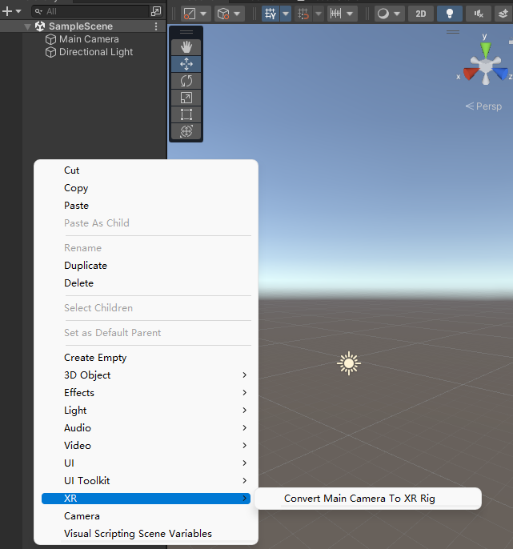

2.Create a 20*20 plane as the ground.

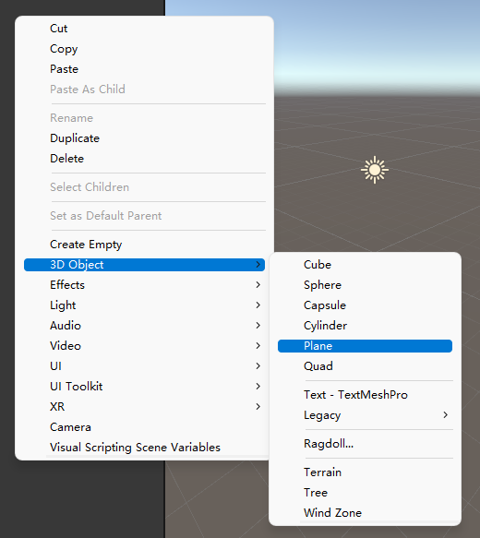

3. Click ‘KAT folder>Perfab folder>KATDemowalker perfab’, drag and drop it to the scene, and check ‘Mesh Renderer’ to display the capsule body so that you can observe the steering and movement. Or directly add the ‘KATXRWalker script’ to the object that needs to control the movement.

You’ll see this figure once the script has been added to the item:

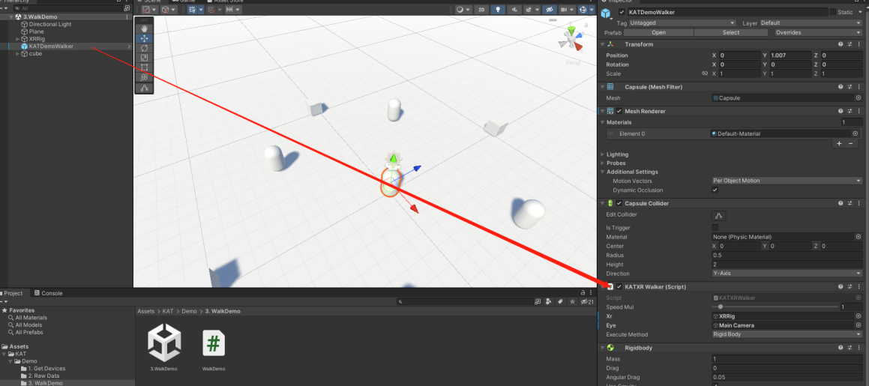

4.Unify the x, z coordinates of the prefab and the XRRig to simulate a real scene with a VR headset, and randomly place several structures in the scene to distinguish the rotation direction in the headset.

5.Click on the prefab, and set it in the script column as below.

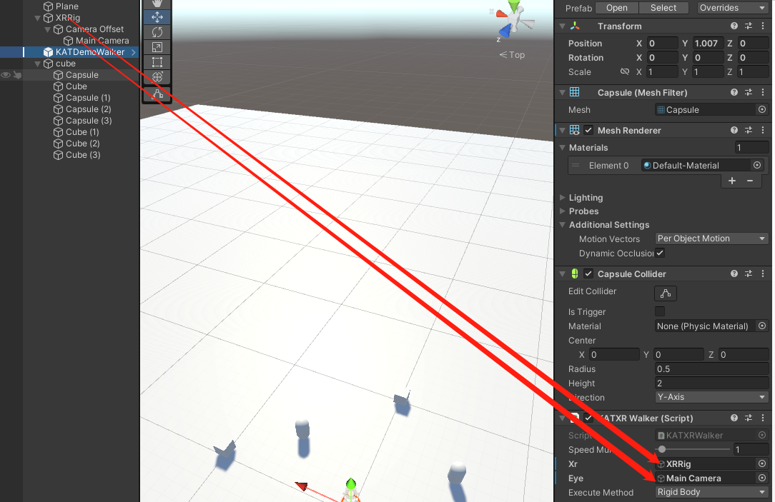

There are also options here to set the movement speed of the prefab

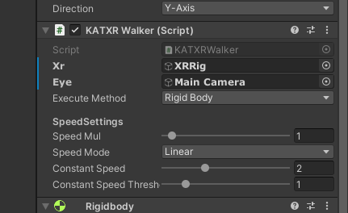

#### (2)Demo

* ‘WalkDemo - The Scene’ in this file is a simple walking Demo made with the SampleScene file (Unity project>Asset>Scene>SampleScene), which can realize the control of steering and movement of the capsule with KAT VR device. This is the simplest quick adaptation scene.

#### (3)Prefab

This folder contains a prefab named ‘KATDemoWalker’. You can refer to the implementation method in ‘KATWalkDemo’ to add the prefab to the required scene to realize the control of walking with a KAT VR device.

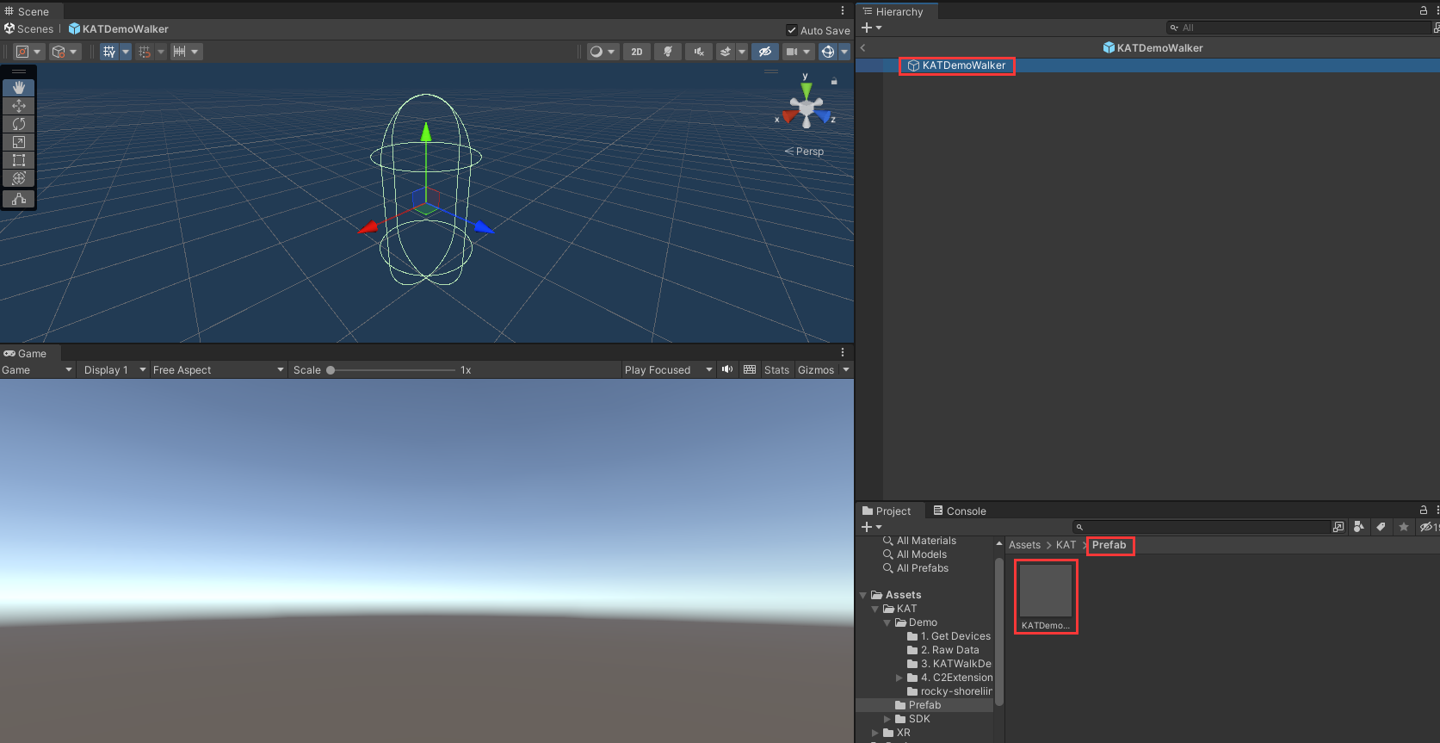

#### (4)SDK

1. **Plugins -**The folder contains “dll” file named KATNativeSDK which is necessary to obtain device information.
2. KATNativeSDK is a must to obtain device information.

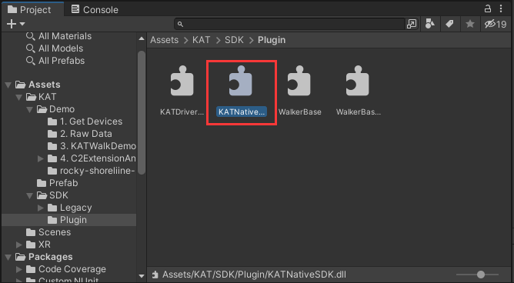

1. The other files:

* Native data acquisition method:

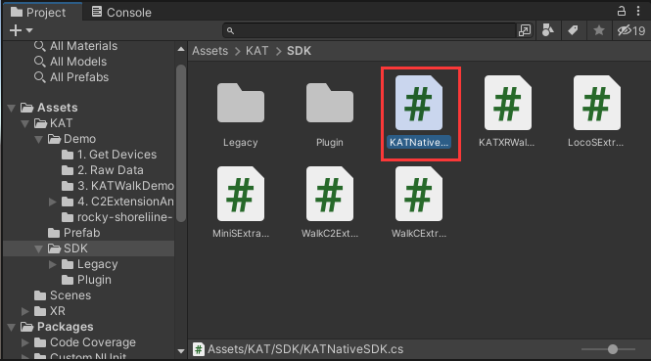

* Mobile prefab script

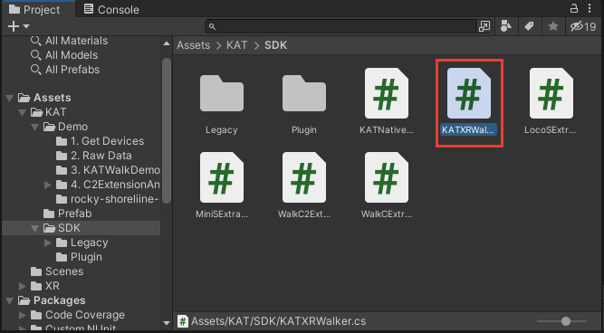

Note: ‘ExtraData’ only consists of device debugging data, and there is no need to pay too much attention to it.

## 4.Debug and build the app

### KAT VR Devices

* Model: KAT Walk mini S, KAT Ioco S, KAT Walk C, KAT Walk C 2 (corresponding development equipment model).
* Make sure the corresponding KAT VR device is correctly connected to the computer and the corresponding software recognized that the displayed data is normal
* If the KAT VR device cannot be connected to the computer for some reasons, you can use the ;KAT Device Simulator; software in the ‘KAT Unitylntegration SDK Development Kit’ to simulate hardware connection and data output.

Take the ‘WalkDemo’ in the SDK folder as an example, double-click the ‘WalkDemo Scene’ in the folder and click ‘play’, then click the Scene Window after loading, and open the ‘KATDemoWalker’ in the scene or the object with the ‘KATXRWalker’ script added. After the preparation is completed, rotate the direction sensor of the device or use the KAT Device Simulator to simulate the input direction to see if the capsule body will change with the device rotation or the KAT Device Simulator simulation input change; then input the speed through the device or the KAT Device Simulator to see if the capsule body ~~It~~ will move towards the current calibration direction.

### VR HMD

VR HMD can be used to debug and run applications. For the development method of the corresponding headset, please refer to the official developer website of the HMD of your choice.

## Build Settings：

Take ‘KATWalkDemo’ as an example:

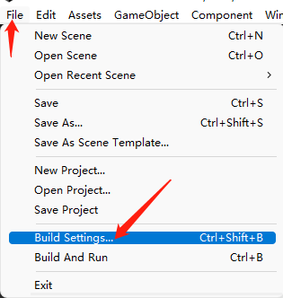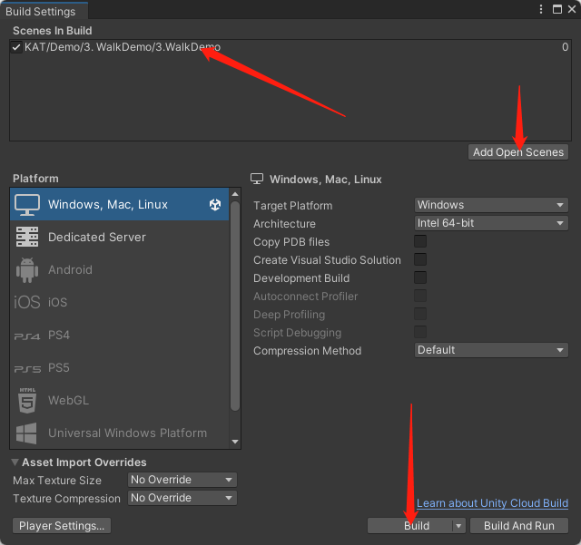

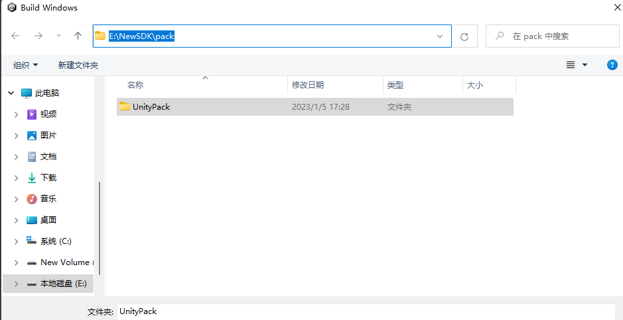

After the setting is completed, it will shown as the figure below:

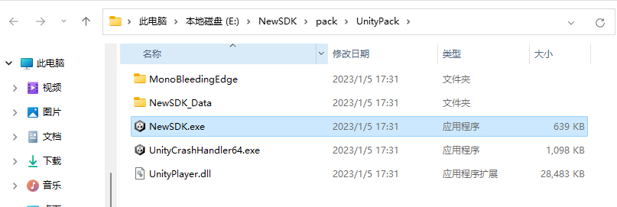

## Developer Best Practices Guide:

COMING SOON